**FPT International School**

--- o0o ---

PROJECT

VENUS HANDICRAFT

Batch: T2205E

Semester: I

Group: 3

|  |  |
| --- | --- |
| * Student1386876 * Student1386542 * Student1386285 * Student1386884 * Student1386217 | * Nguyen Duc Quyen * Nhu Dinh Hoc * Tran Thi Thu Hang * Nguyen Van Thuy * Kieu Duy Giap |

Hanoi, November 2022

## Acknowledgments

We would like to express our deepest appreciation to all those who provided us with the possibility to complete this report. A special gratitude we give to our project instructor, Ms. Dang Kim Thi, whose contribution in stimulating suggestions and encouragement helped us to coordinate our project, especially in writing this report.

**Table of Contents**

Acknowledgments 2

1. Synopsis 4

1.1 Problem Statement. 4

1.2 Requirements 4

1.3 Implementation environment 4

2. Analysis of User Stories 5

2.1 View 5

2.2 Give feedback and ratings 5

2.3 Add items to the cart 5

3. SCREEN SHOT 6

3.1 HOMEPAGE 6

3.2 ABOUT 11

3.3 GALLERY 12

3.4 PRODUCTS 15

3.5 PRODUCT DETAIL 16

3.5.1 Iron Handicrafts detail 16

3.5.2 Glass Handicrafts detail 18

3.5.3 Brass Handicrafts detail 19

3.6 CONTACT US 21

4. Summary 21

# Synopsis

## 1.1 Problem Statement.

Venus Handicrafts is certified company engaged in manufacturing and exporting of Decorative Handicrafts to global importers, wholesalers and retailers since 1972.   
The ever-increasing acceptance of our products on global platform highlights our market presence and goodwill. The company has maintained its market value throughout the world. To enhance its value the organization wants to change the look and feel of the website for which they have approached you.

The objective is to create a website for them with the below-mentioned requirement specifications.

The website is to be developed for the Windows Platform using HTML5, JavaScript, and Geolocation. The site should work well in all leading browsers including Chrome, IE, Firefox etc

## 1.2 Requirements

1. The Home Page should be created with proper sections, graphics and with a suitable logo
2. Link on the home page must be included such as Home, About us, Gallery, Contact information, Handicrafts products,
3. The look and feel of the project must be made user friendly and uniformity in the color combination must be maintained.
4. Handicrafts such as:
   * Iron Handicrafts
   * Glass Handicrafts
   * Brass Handicrafts
   * Wood Handicrafts
   * Aluminium Handicrafts
   * Handicraft Decorative
   * Tables wares
   * Home Décor
   * Candle Accessories
   * And other additional products
5. Navigation of the project must be made smooth.
6. Site Map
7. Gallery
8. FAQs

## 1.3 Implementation environment

1. Notepad/HTML editor
2. Dreamweaver
3. IE 5.0/ Netscape 6.0/ Google Chrome 98.0.4758.101/ Safari 15.2

# Analysis of User Stories

## 2.1 View

● Products: As a user, I want to view the products categorized according to their types, the brands they are from, their colors, and their discount availability.

When I click on a product, a detailed description of the products will display, including images, price, discount, brief introduction, specification table with a link to document containing a detailed description and manual, ratings, and color variants.

● Brands: As a user, I want to view the information of the brands in this organization. Information includes general information, contact email, contact number, and location. The location also integrates the Geolocation API. When I click on the email address, my email address will automatically invoke sending mail to that address. On the general information page, a link navigating to the brand’s products should be present.

## 2.2 Give feedback and ratings

The website shall include a comment section where I can post my comments on certain products

## 2.3 Add items to the cart

The items should also be able to be added to the shopping cart. The number of items in the cart will get updated and displayed on the page whenever I click on the cart button.

On the shopping cart page, I will see the list of the products that are currently in the cart. I will be able to remove the items from the cart and modify the quantity of the items either by inserting a number in the input box or clicking the increment/decrement buttons. The price of items and the total bill’s worth will be modified accordingly. our website, displaying details such as customer's name.

# SCREEN SHOT

## HOMEPAGE

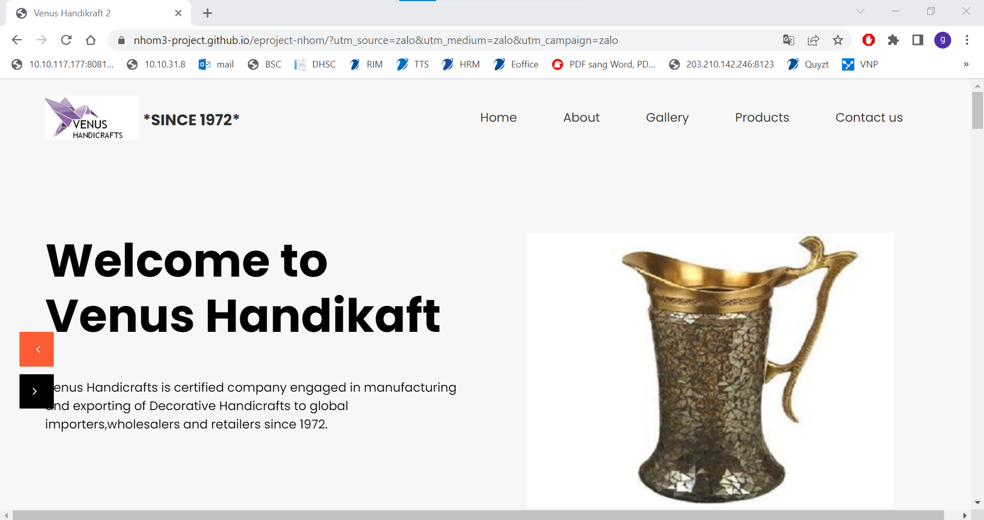

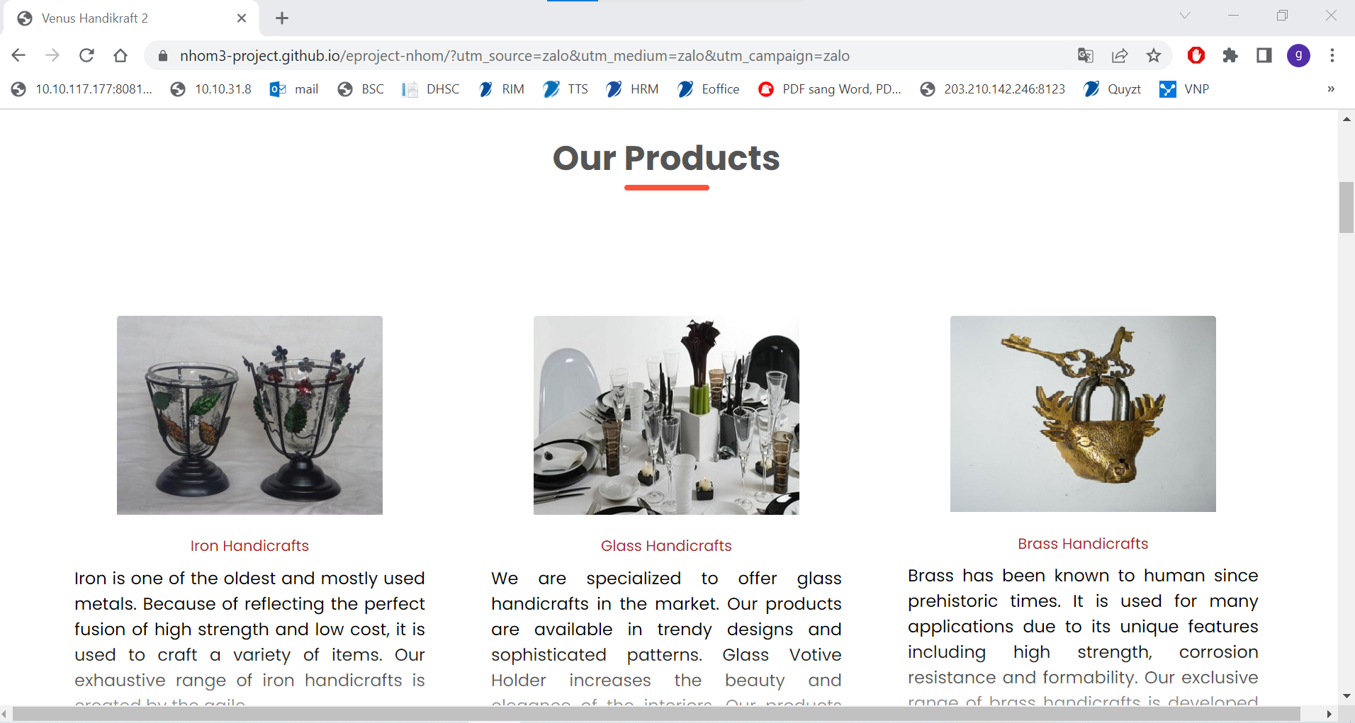

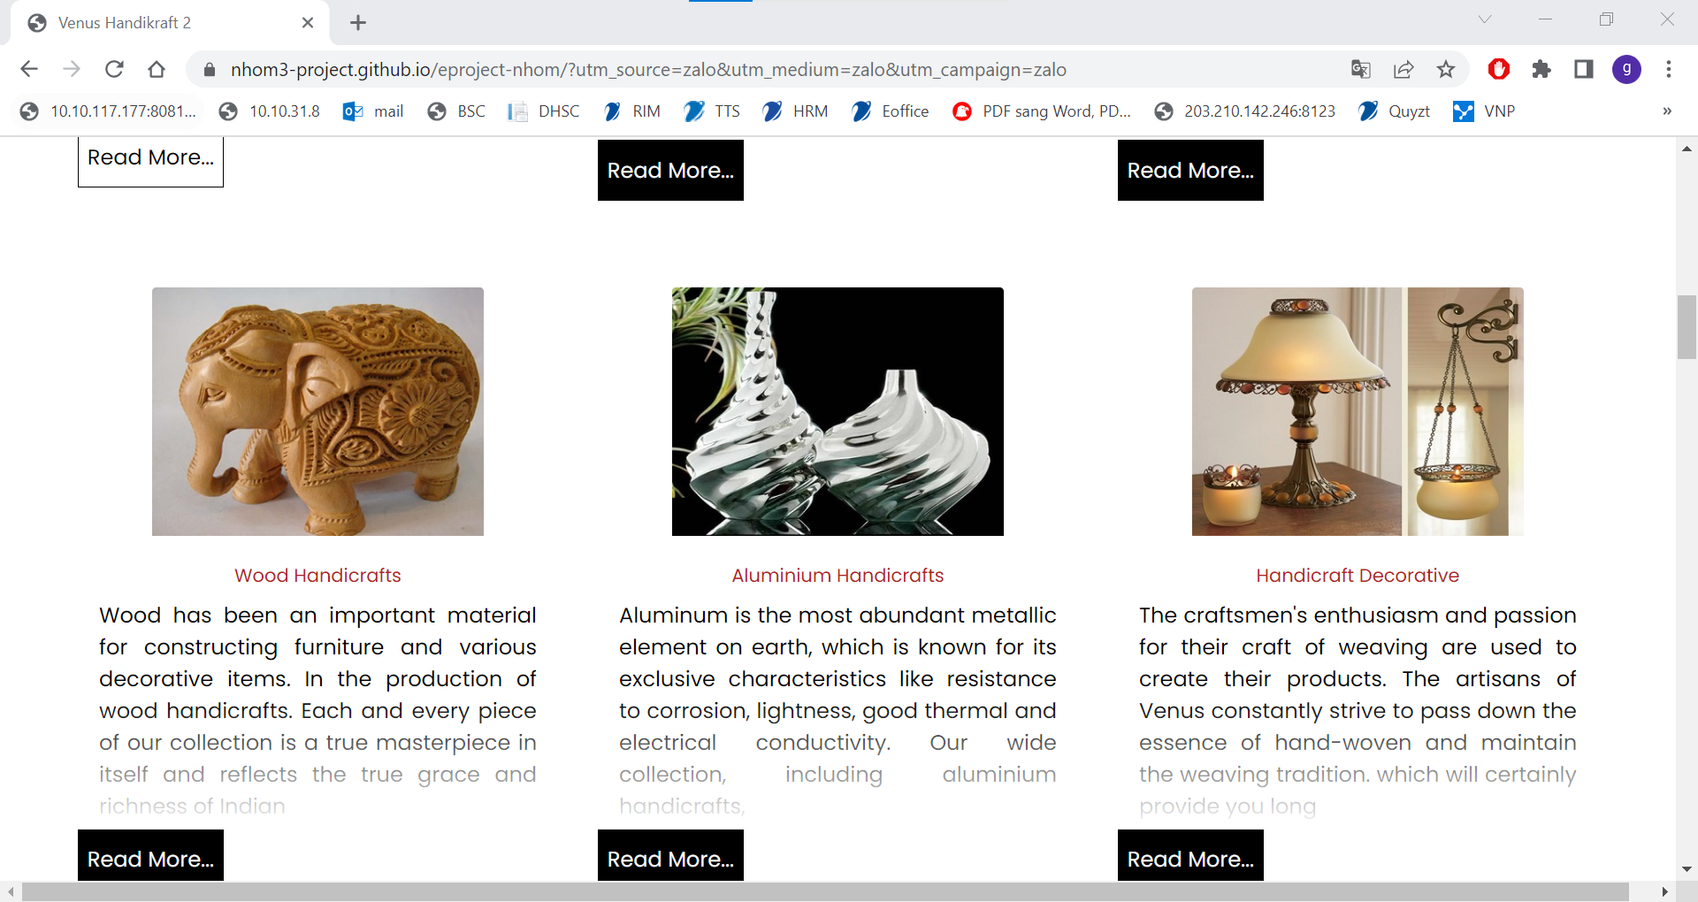

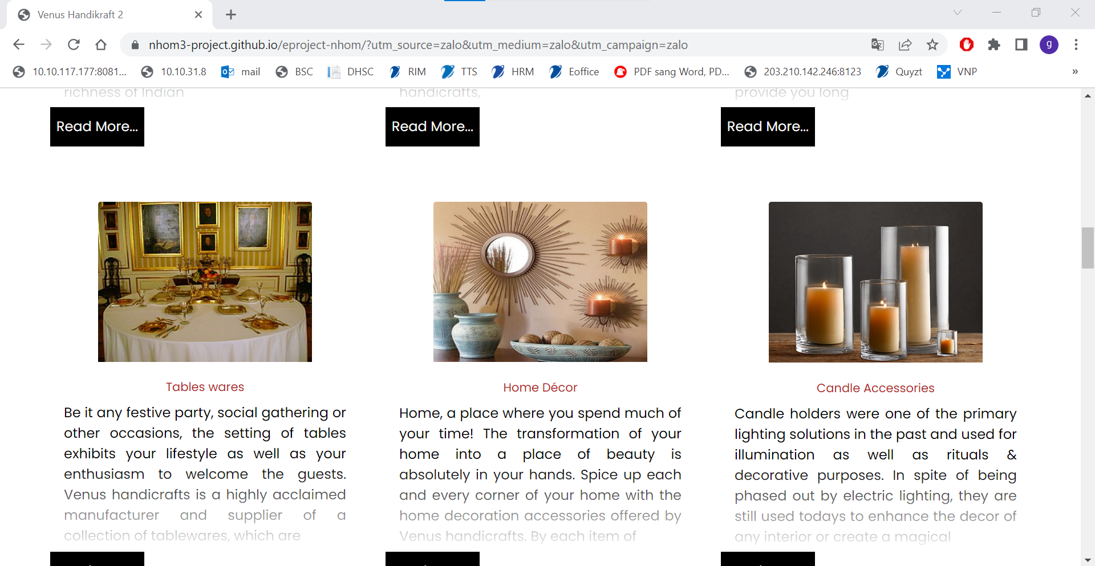

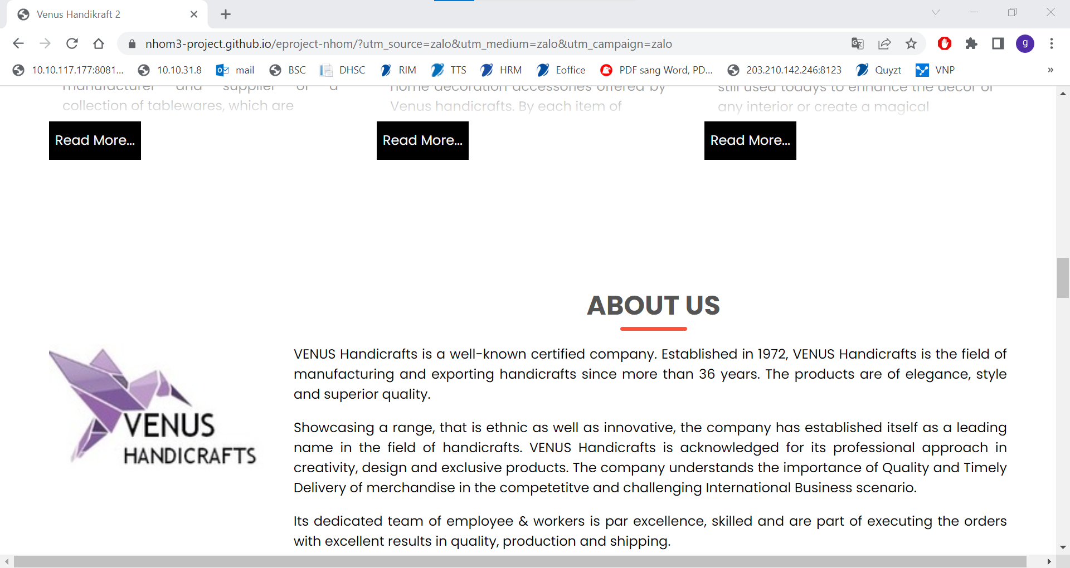

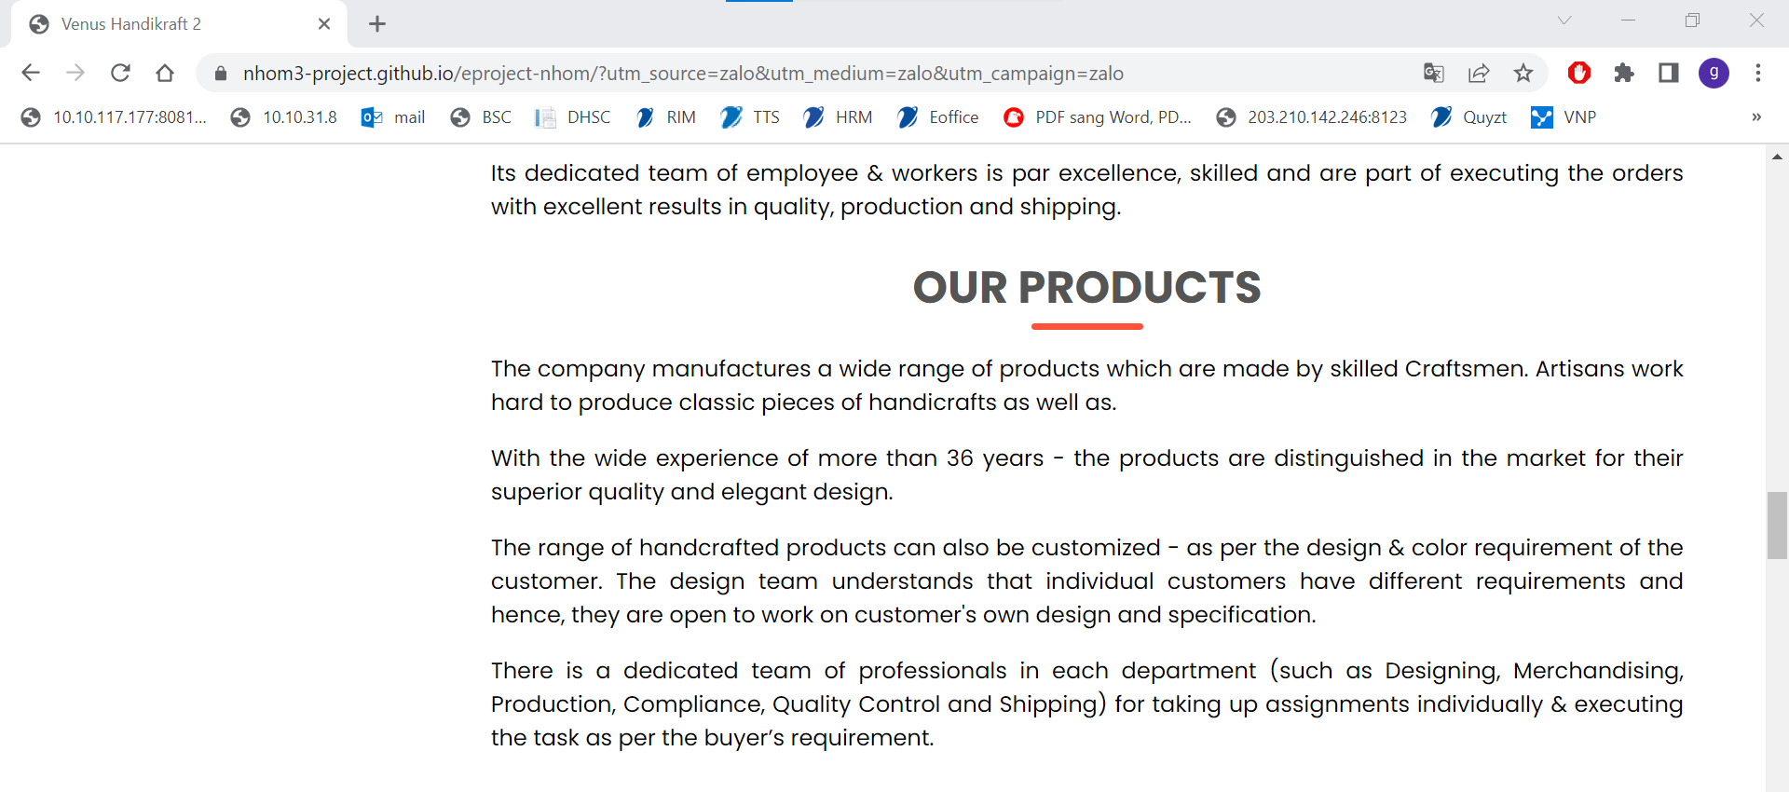

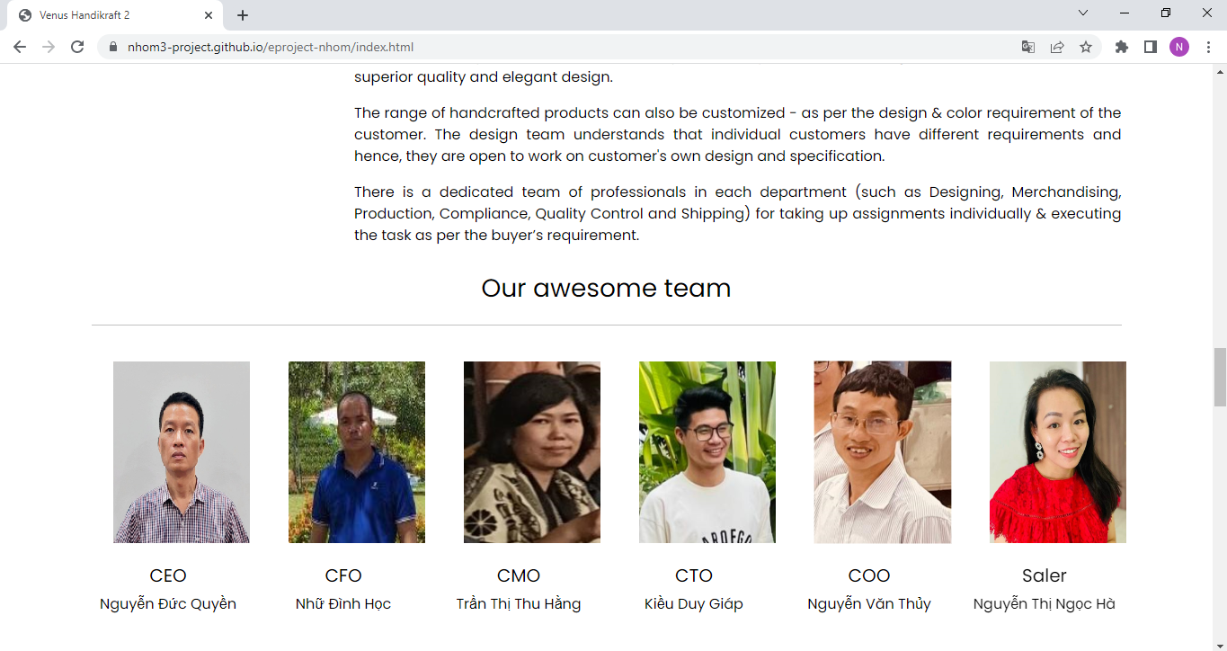

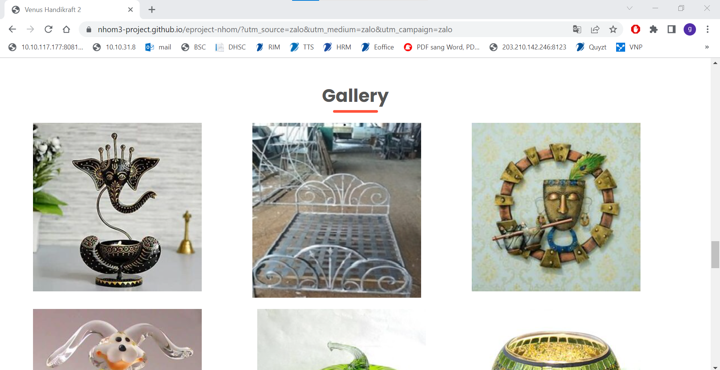

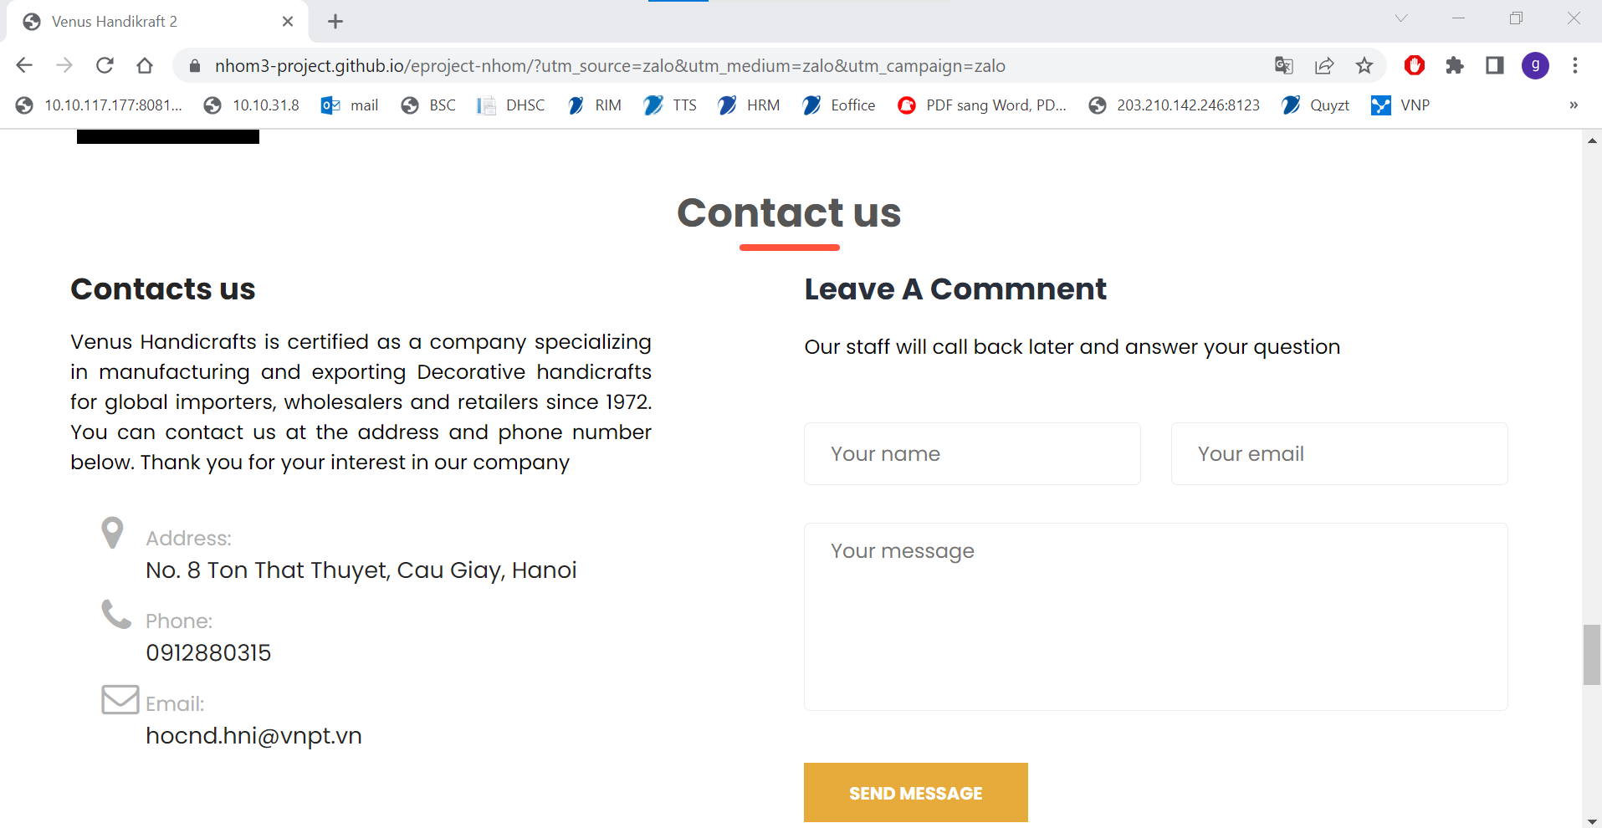

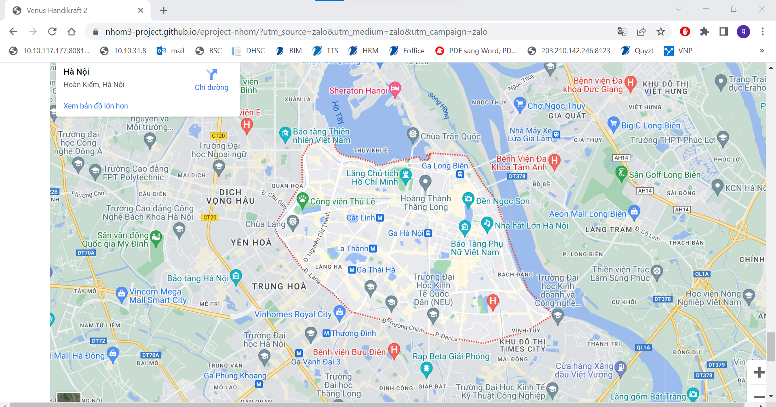

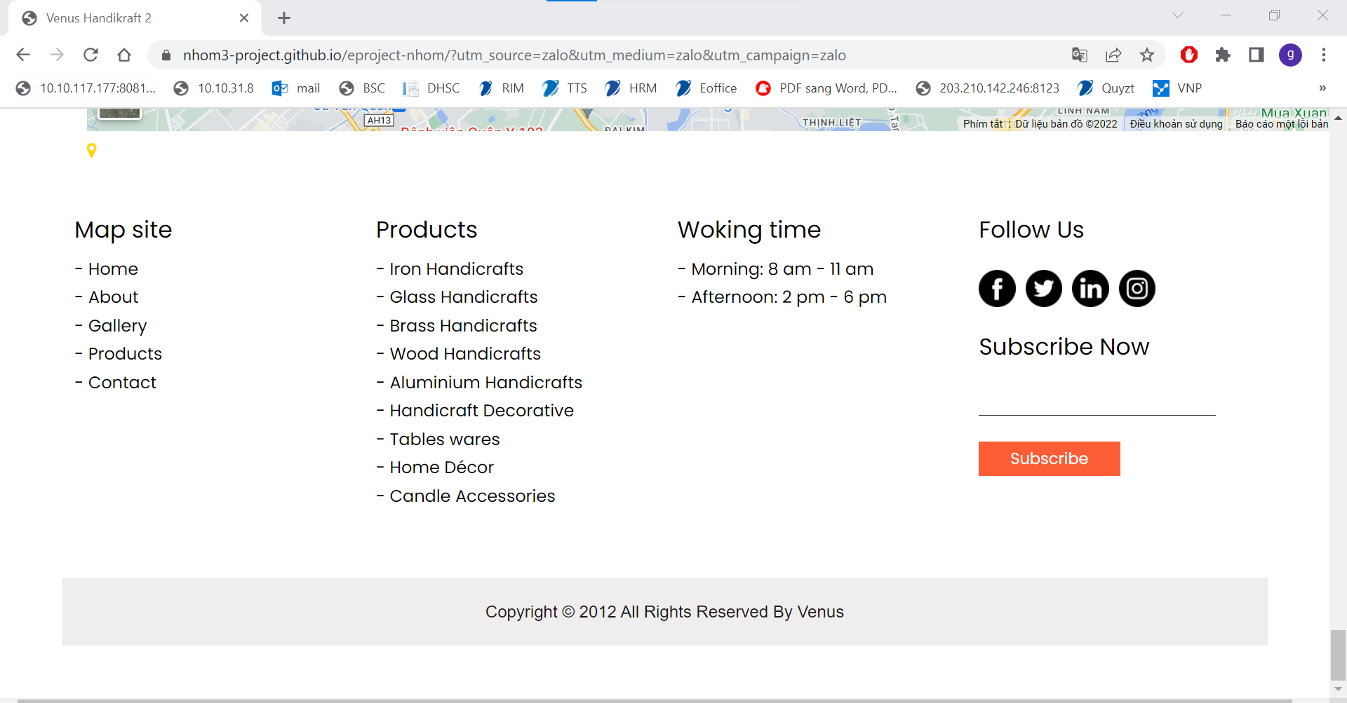

## ABOUT

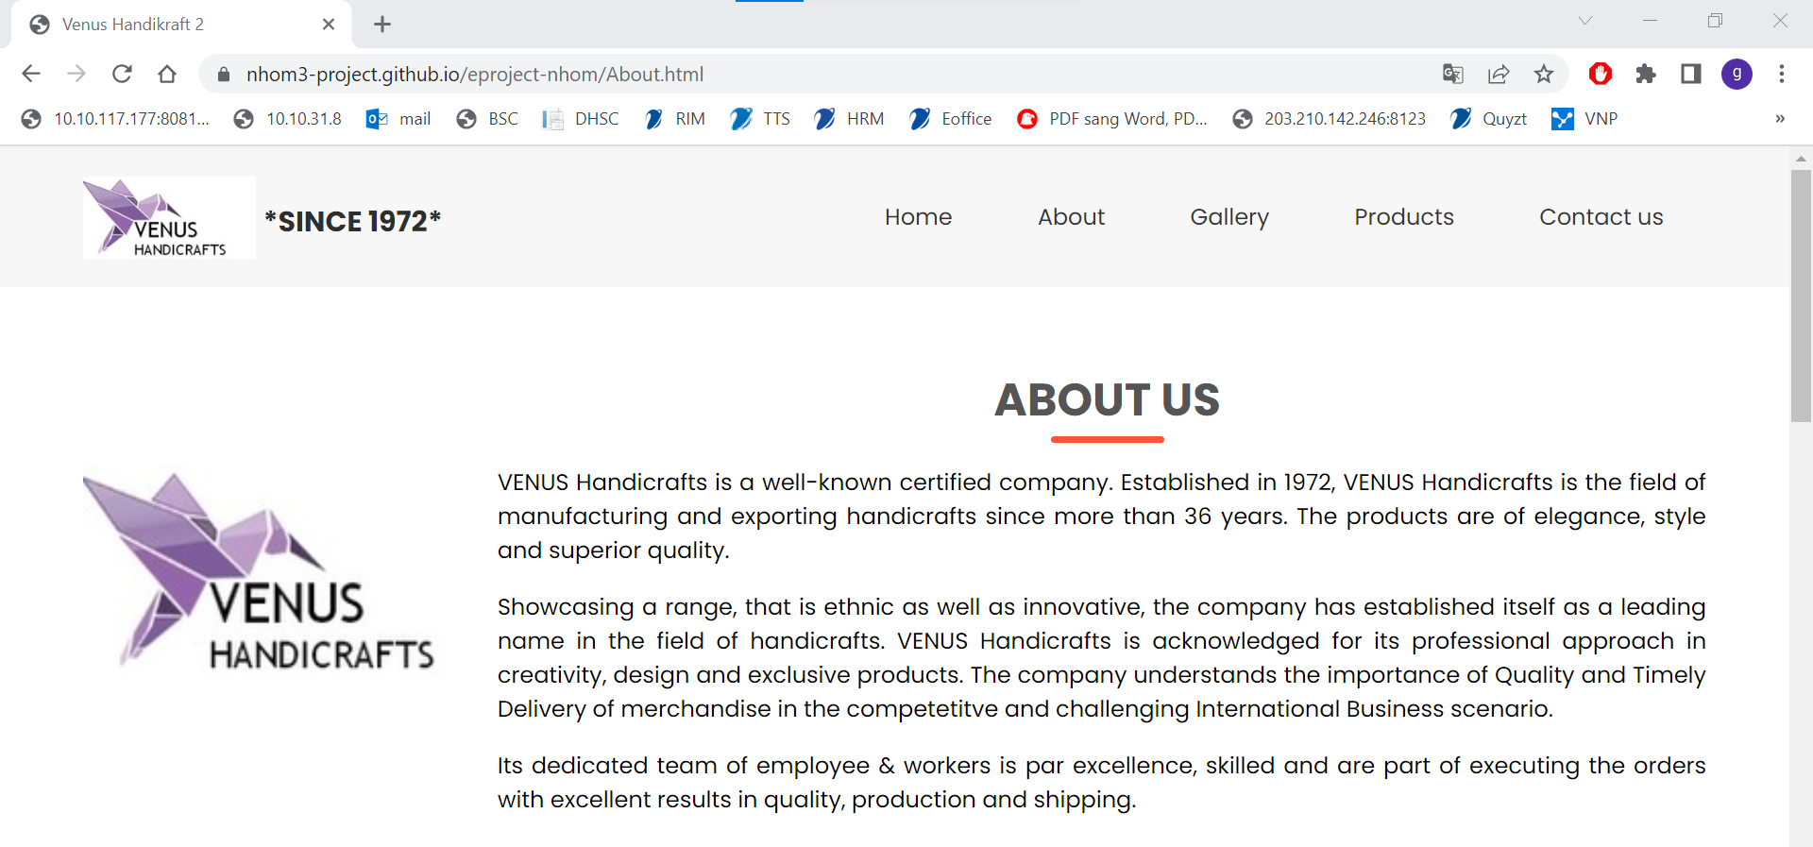

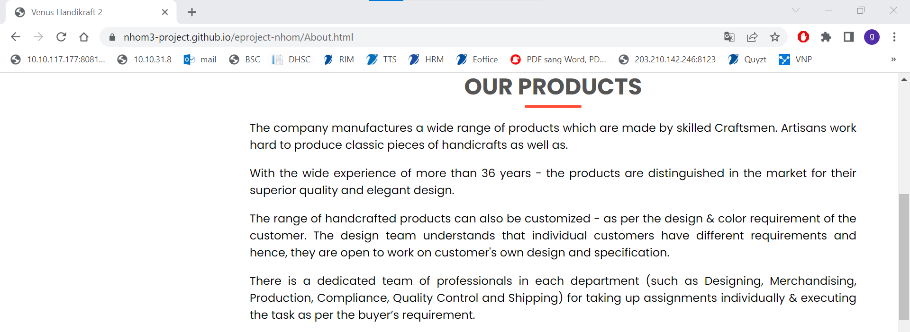



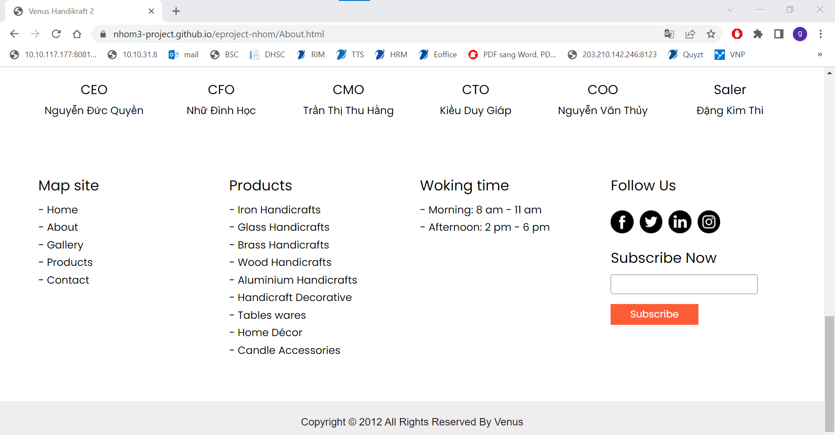

## GALLERY

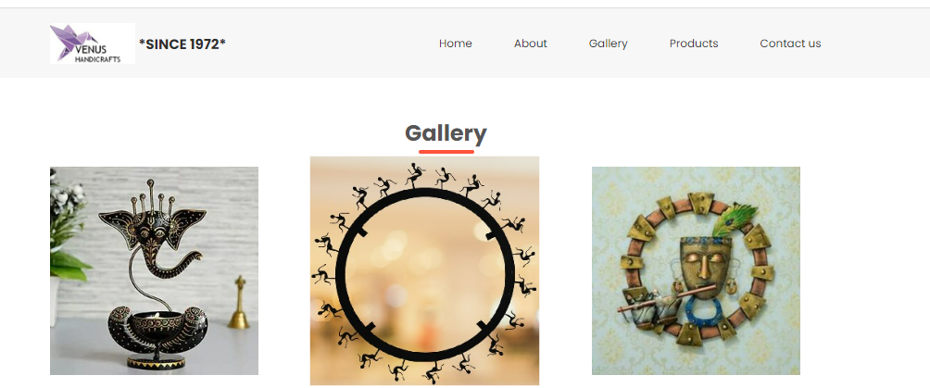

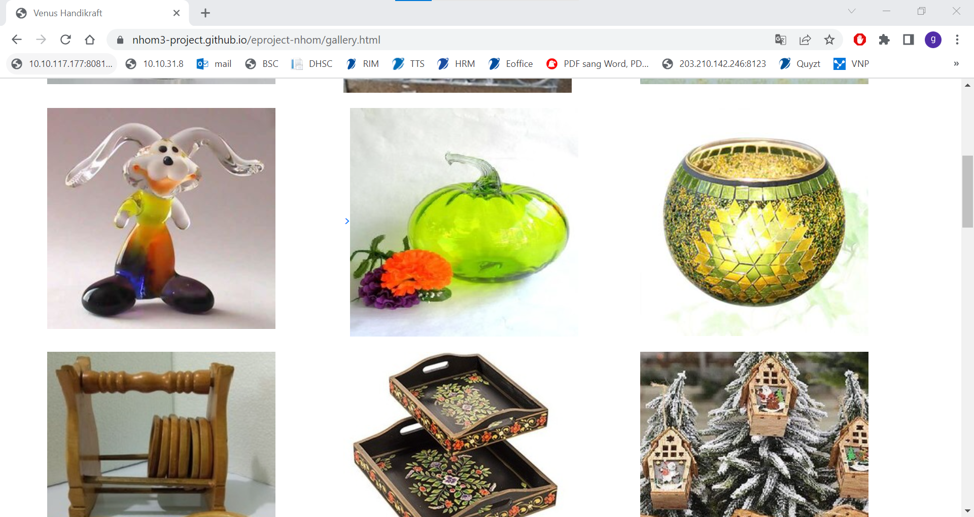

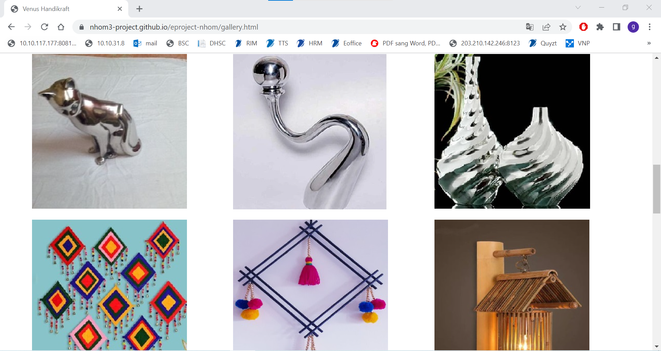

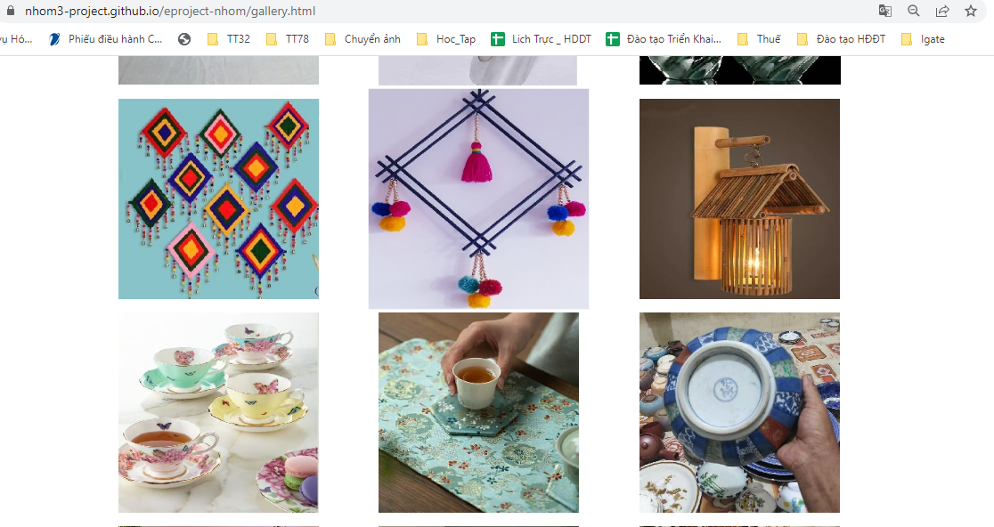

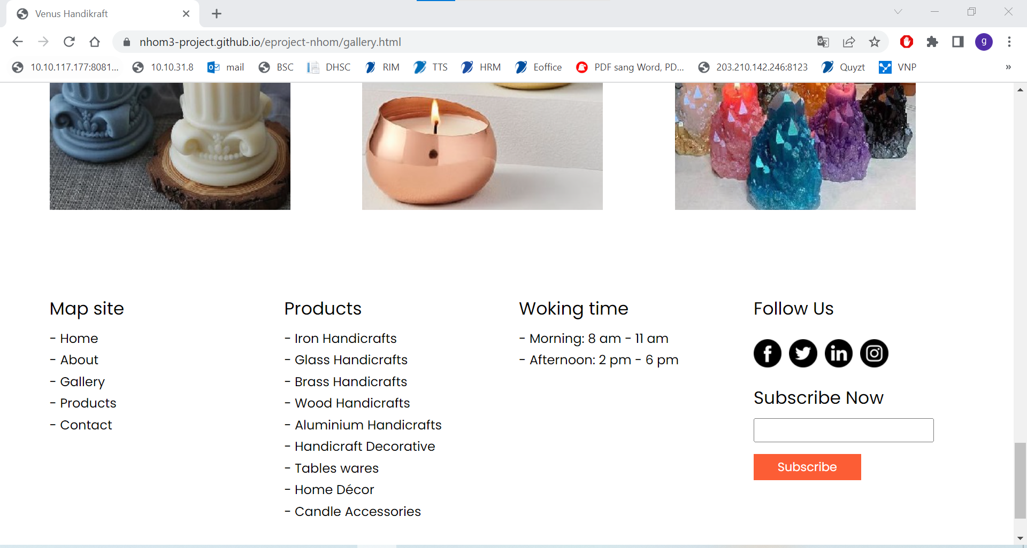

## PRODUCTS

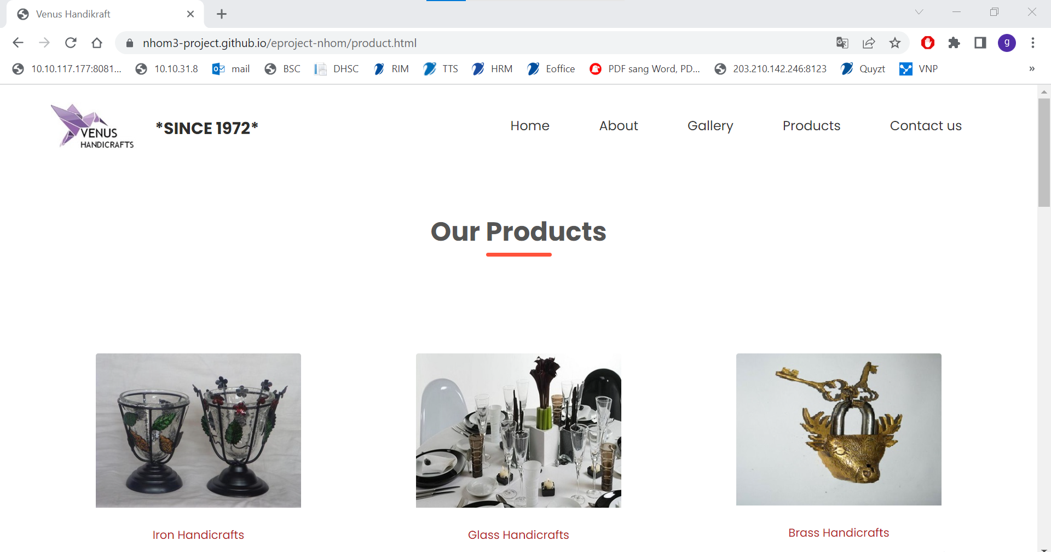

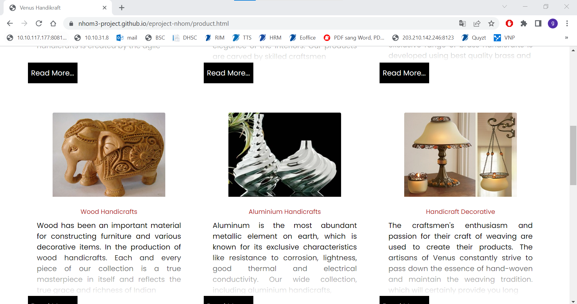

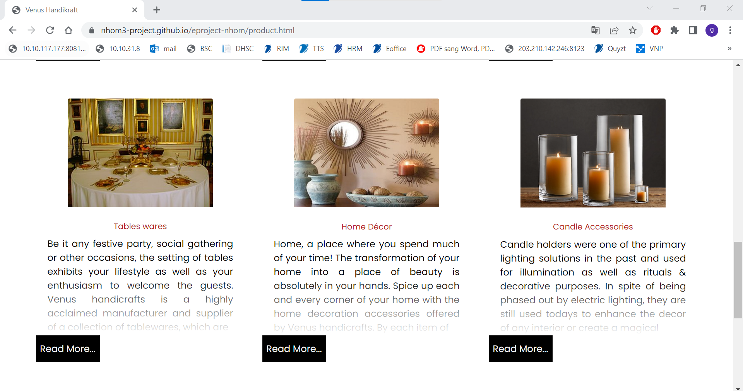

## PRODUCT DETAIL

Team shot screen some products detail for example.

### 3.5.1 Iron Handicrafts detail

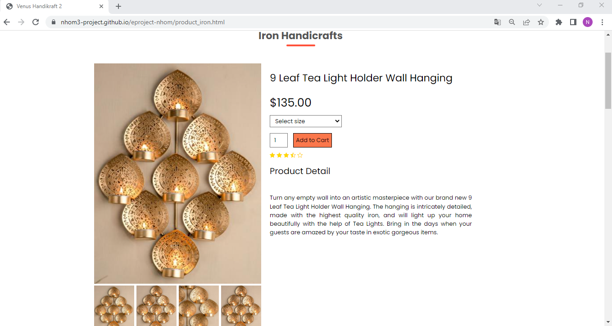

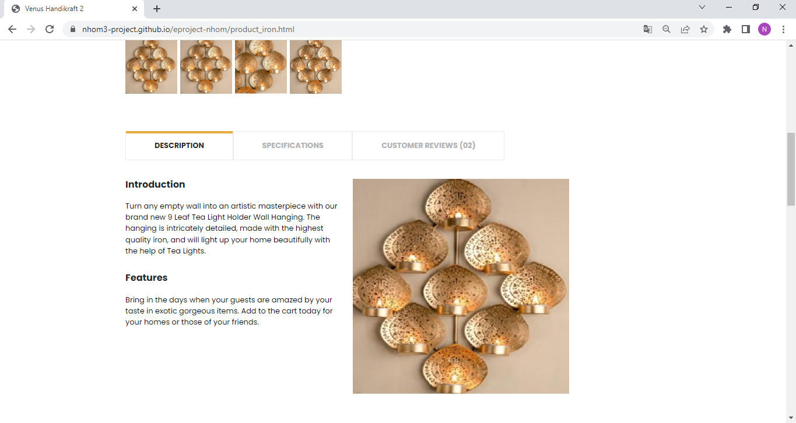

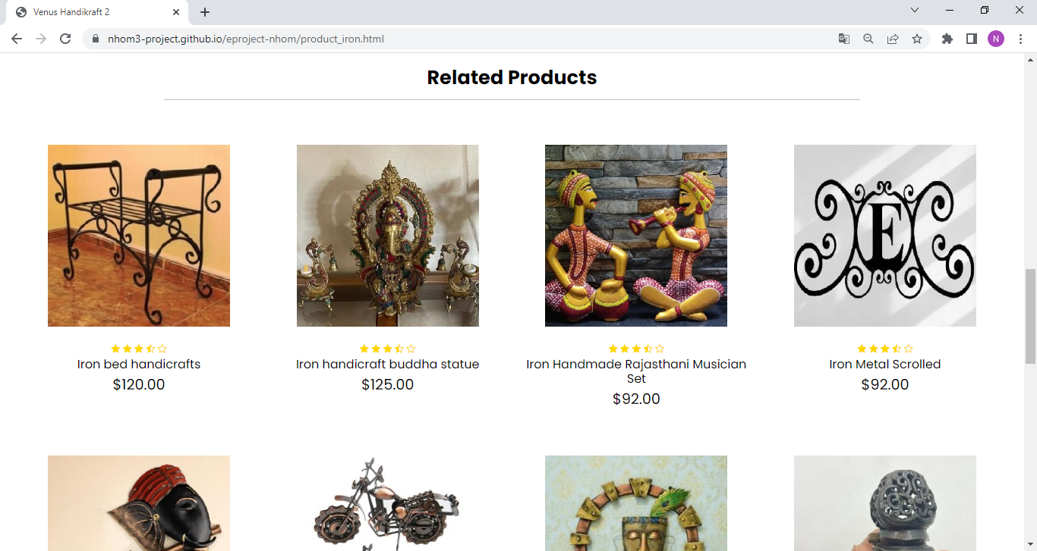

### 3.5.2 Glass Handicrafts detail

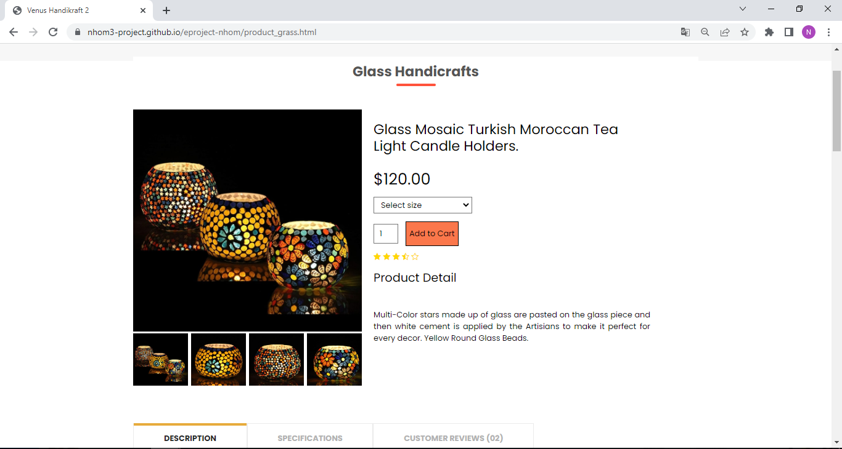

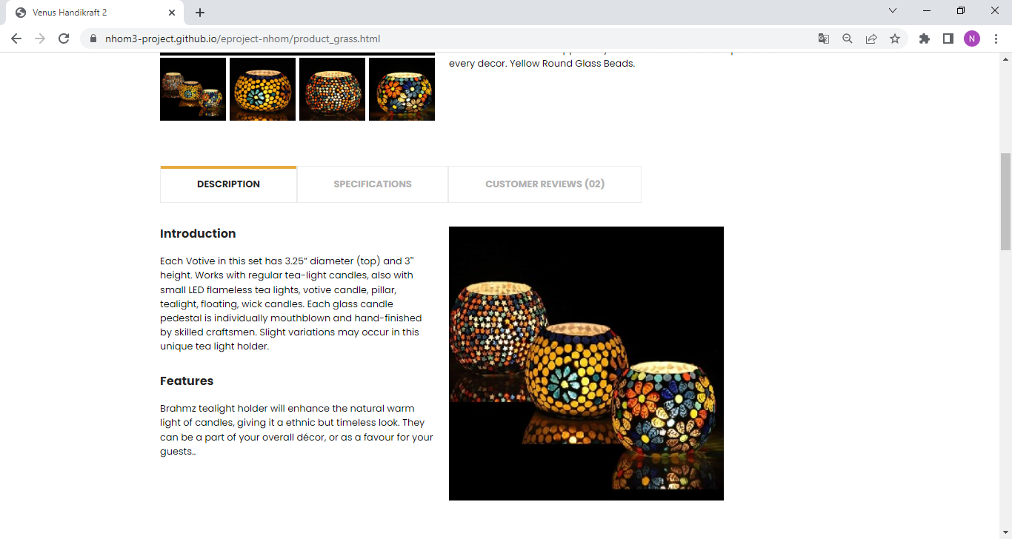

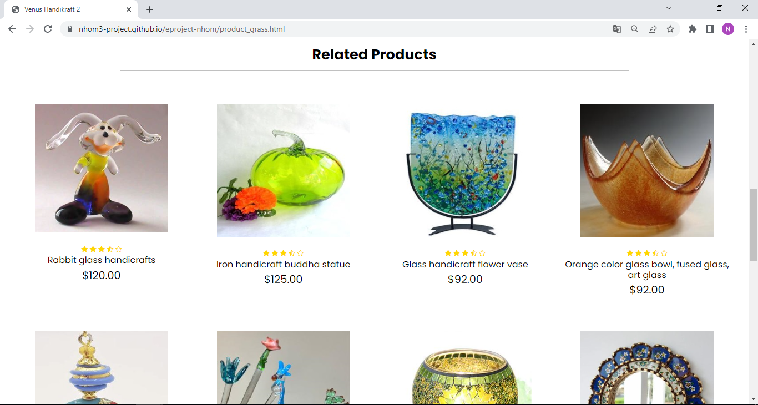

### 3.5.3 Brass Handicrafts detail

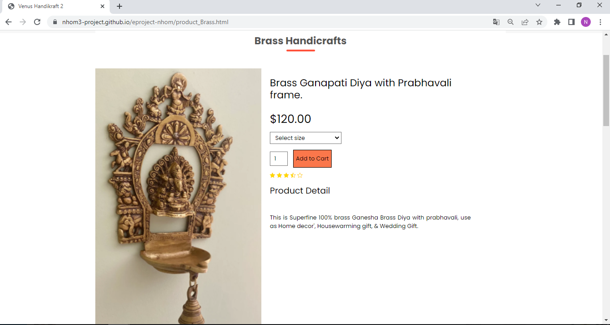

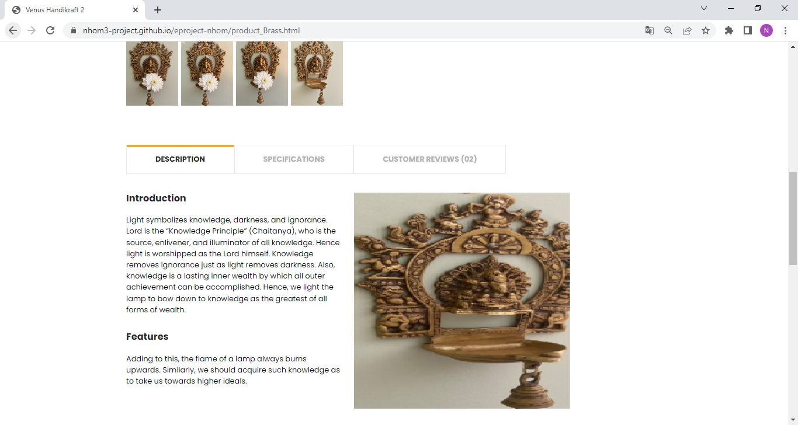

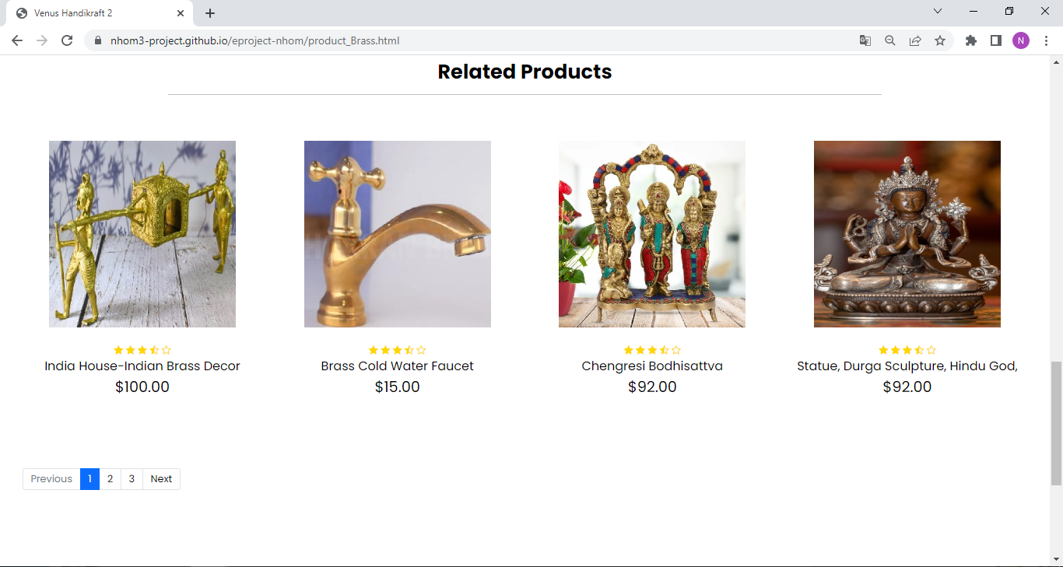

## CONTACT US

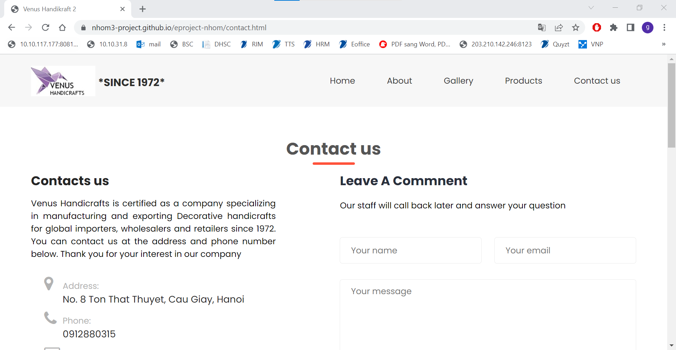

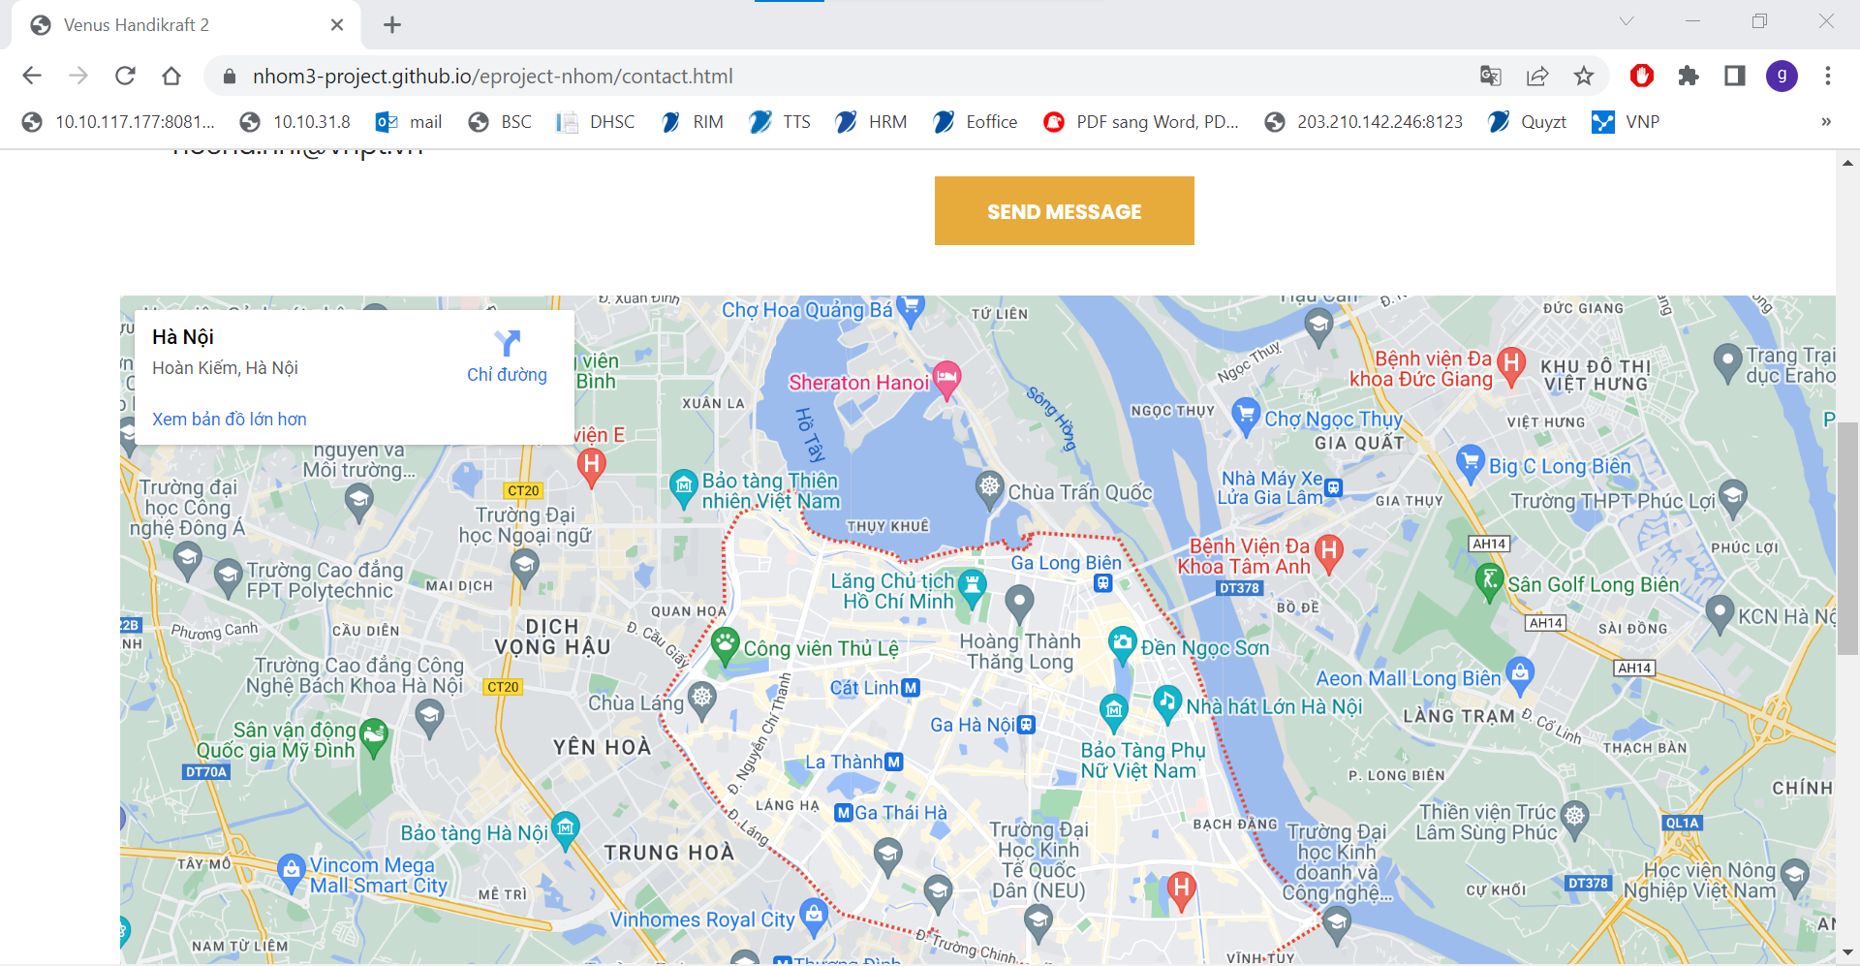

# Summary

This website is done thanks to our teacher (Mrs. Đặng Kim Thy), our hard-working and responsible team members.

|  |  |  |
| --- | --- | --- |
| ID | Name | Task |
| 1 | Nguyen Duc Quyen | Frame work, Scripts, Testing, Team Coordinator. |
| 2 | Nhu Dinh Hoc | Product Detail, Cart, Checkout, Scripts, Data, Team Coordinator. |
| 3 | Tran Thi Thu Hang | Homepage, Data, about us, Team Coordinator. |
| 4 | Kieu Duy Giap | Data, Report. |
| 5 | Nguyen Van Thuy | contact us, Scripts, Testing |